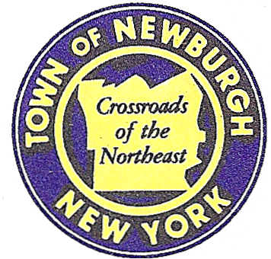

TOWN OF NEWBURGH
_______Crossroads of the Northeast __________________________
OLD TOWN HALL
308 GARDNERTOWN ROAD NEWBURGH, NEW YORK 12550

PLANNING BOARD
JOHN P. EWASUTYN, CHAIRMAN
TELEPHONE 845-564-7804
FAX 845-564-7802
E-MAIL: planningboard@townofnewburgh.org

PLANNING BOARD AGENDA

May 3rd, 2018

*PLEASE NOTE: The Planning Board Meeting will start at 7:00 P.M. and all Applicants/Representatives
are to be present at that time. The Meeting will be held in the Meeting Room of Town Hall,
located at 1496 Route 300, Newburgh NY.*

- Gold’s Gym (18-07 ) INITIAL APPEARANCE
15 Racquet Road AMENDED SITE PLAN
Section 86 , Block 1, Lot 26.21
Zone: IB
Rep: Mauri Architects, PC
303 Mill Street
Poughkeepsie, NY 12601

2. Serviss Timber Harvest (18-04) PUBLIC HEARING
Union Avenue
Section 34, Block 1, Lot 25.2
Zone: R2 & RR
Rep: Christopher Prentis

*WORK SESSION*
Project Readiness Discussion scheduled for 6:00 p.m. in the Meeting Room of
Town Hall on Thursday, May 3rd, 2018.*

PLANNING BOARD BUSINESS
WORK SESSION

.

*WORK SESSION*
Project Readiness Discussion scheduled for 6:00 p.m. in the Meeting Room of
Town Hall on Thursday, May 3rd, 2018.*

